
Prosperity Planning
Today we are faced with rising prices and juggling to manage all those expenses against the income that is coming in. Old adages about pulling in your belt with a budgeting system have proven not to work for most people, especially with the negative thoughts of denying yourself something.
Don’t throw up your hands in defeat though! Take time to understand what the must pay key items are, the absolute essential needs, not simply what you may want.
Needs are the fixed expenses (ex. rent, mortgage, utilities, taxes, insurance, transportation costs & food), as well as key savings such as an emergency fund, plus a short-term savings account – yes, these are all needs to keep you out of the clutches of the credit card/finance companies. Paying high interest to financial institutions is not part of your family becoming more prosperous.
Once you have figured out this hard limit, you then know what you have left to spend on you and/or your family for fun, self care or treats. Using this process, eliminates the detailed tracking that is never kept up due to resentment. You can take that leftover amount and choose each pay or month if you go out to eat, buy that fancy coffee, spend on new clothes, golfing, fishing, or spoiled with a massage.
The other thorny problem is dealing with debt. It’s helpful to consolidate to reduce the number of payments, pay off the highest interest rate first and ideally only have one loan at a time to reduce the balancing act. Work towards a ‘pay as you go’ approach, not stashing cash that makes little if any interest and always ensure you make the minimum payments in the grace period.
Involve the whole family in the prosperity plan to get the most success and teach your kids too!

Sudbury’s own Roger Nash, the first Poet Laureate in our city, has once again put pen to paper and completed his latest book of poems. It has now been published, just in time for summer reading.
You can check out his latest book called:
"A Game of Marbles" on eBay
https://www.ebay.ca/itm/407065904638
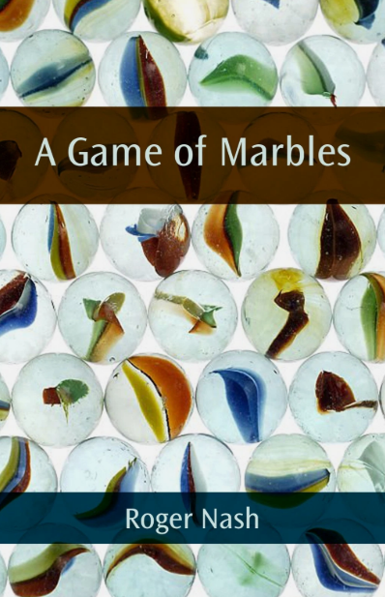

In this issue we feature “Gloss Theory” beauty studio, locally owned and located at 1258 the Kingsway. They believe you deserve elevated self care, where everyone experiences a relaxing and positive atmosphere to unwind and leave feeling beautiful
Here, nail art is real art and the attention to detail is perfection! You may choose from manicures, pedicures, nail enhancements, hair treatments, lash lift & tints, lash extensions, brow threading & waxing, microblading, lamination, henna brows, face & body waxing (all genders)

Sudbury Secrets...
